**Task 18: Automated Apache Deployment with Ansible: Simplifying Web Server Setup**

**Ansible** is an open-source automation tool developed by Red Hat. It is used for configuration management, application deployment, task automation, and IT orchestration. Ansible simplifies managing large-scale IT infrastructure by automating repetitive tasks and ensuring consistency across systems.

Apache is one of the most widely used web servers, known for its flexibility and scalability in hosting websites and applications. Automating its deployment with Ansible streamlines the process of setting up web servers in dynamic and large-scale environments.

This task involves leveraging **Ansible**, a powerful automation tool, to efficiently install and start the **Apache HTTP server** (commonly referred to as httpd or apache2) across multiple servers. This automation ensures that the web server is deployed uniformly on all target systems without manual intervention, saving time and reducing the risk of configuration errors.

**Objective:**

**The primary goal of this task is to:**

* Install the Apache server on all target nodes.
* Ensure the Apache service is enabled to start at boot.
* Start the Apache server to make it operational immediately.

**Practical Implementation: Deploying Apache with Ansible (Step-by-Step with Screenshots)**

* 1. I have set up one controller node and three worker nodes to execute this task

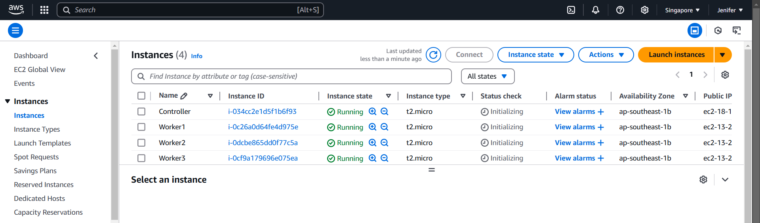

* 1. I have installed Ansible in the controller node

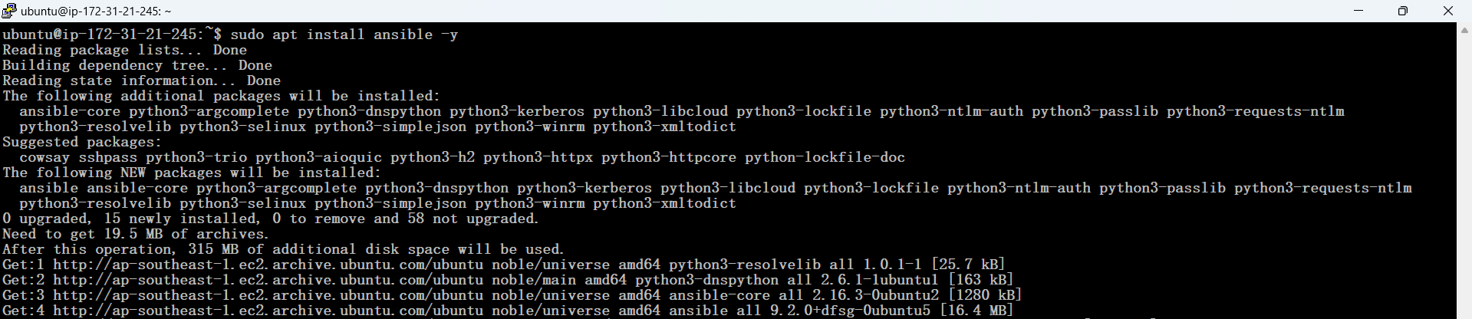

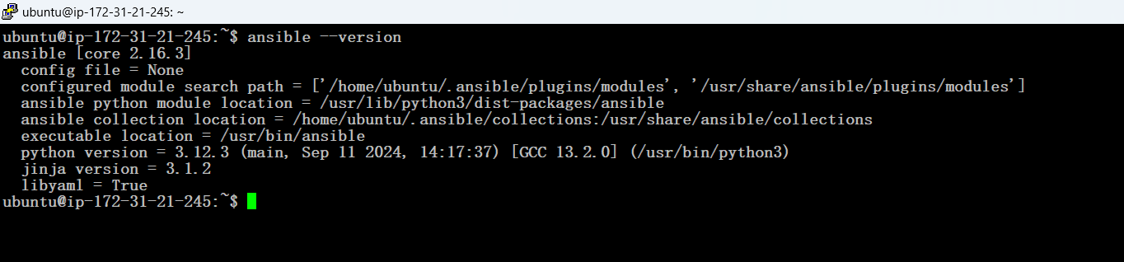

* 1. Set up password-less SSH key authentication between the controller node and the worker nodes for seamless and secure communication.

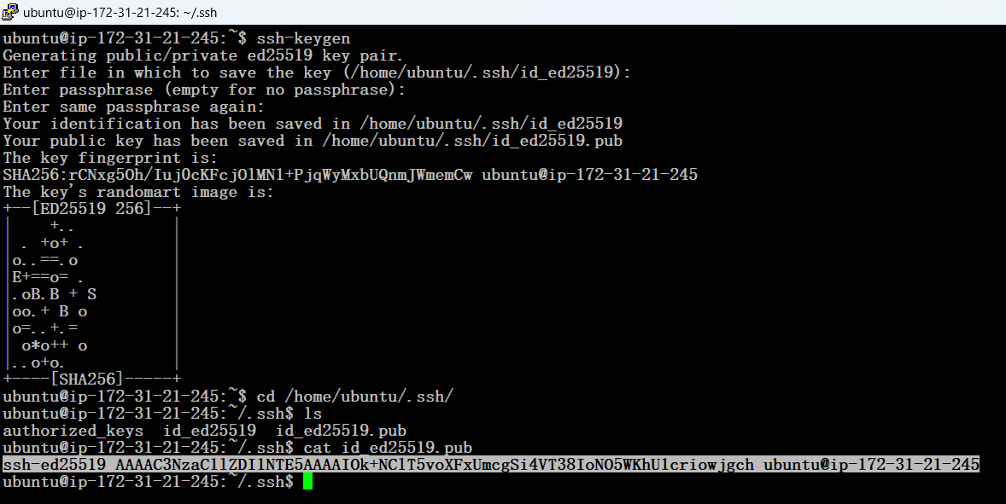

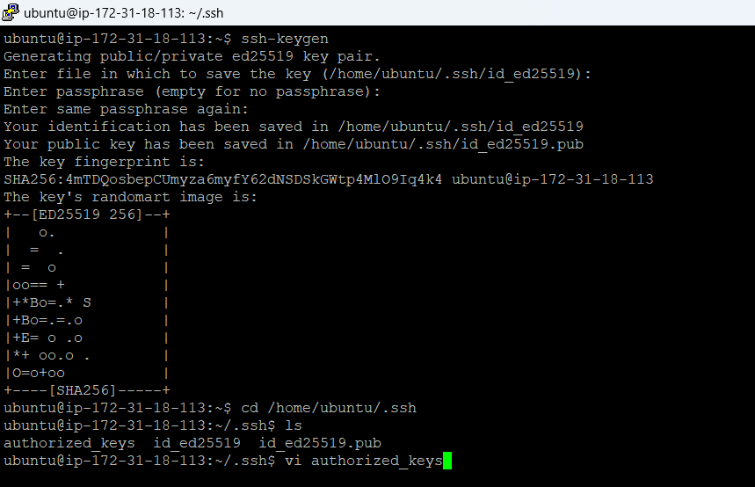

**Authorized keys** are public SSH keys that are stored on a server to grant access to users or systems with the corresponding private SSH keys. They are a crucial part of SSH-based password-less authentication, enabling secure access to a system without requiring a password.

* 1. Storing Controller’s Public key into the Worker node’s Authorized keys



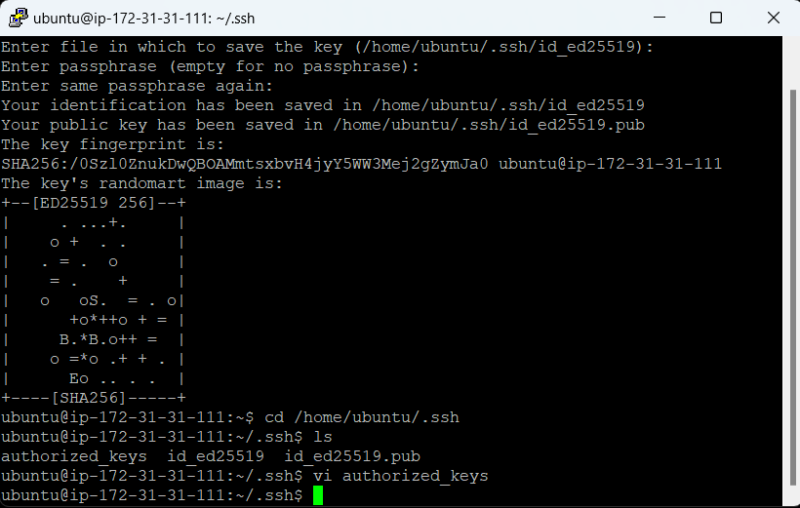

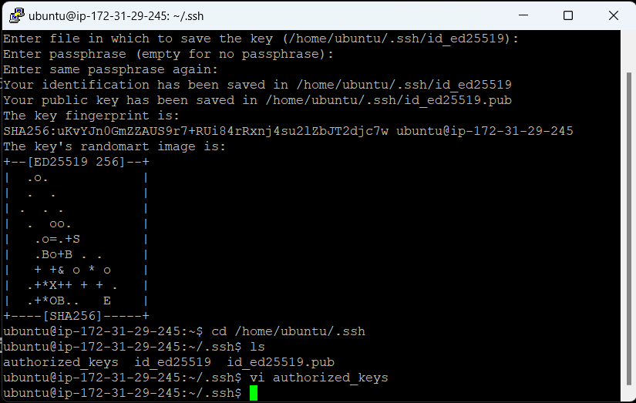

* 1. Creating the inventory file for defining and managing the target nodes in the Ansible setup.

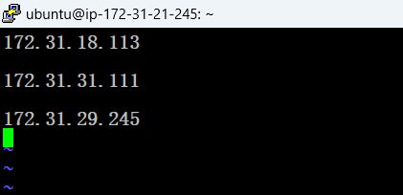

An **inventory file** in Ansible is a configuration file that contains a list of target systems (managed nodes) that Ansible will interact with. It serves as a centralized resource for defining the hosts and groups of hosts, along with their connection details and optional variables.